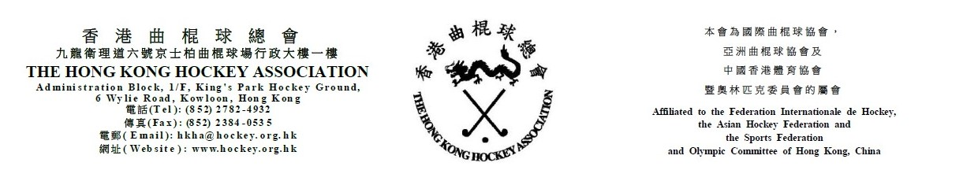

Attendance Form for
The Hong Kong Hockey Association Annual General Meeting
on Tuesday, 31 July 2018
(Please see notes below before completing the form)
The following are authorized to represent __________________________________ (Member Club) at the HKHA AGM on Tuesday, 31 July 2018:-

Authorized to Vote
(tick one box only)
1. _____________________________________ ( )
(Name)
2. _____________________________________ ( )
(Name)
3. _____________________________________ ( )
(Name)

(Name of Club Official) |  | (Signature of Club Official)

(Position of Club Official) |  | (Date)

Notes: (1) Up to three persons can be authorized to attend the meeting. However, only one can be authorized to vote.
- Club officials include President, Chairman, Hon. Secretary, Convenor and Hockey Section Captain.
- This form must be received by the HKHA office no later than 5:00 pm on 17 July 2018.

